**MAC Assignment**

**1.Write about MAC Architecture, function, and channel structure**

### MAC Architecture, Function, and Channel Structure

* **Architecture**:
  + The MAC (Medium Access Control) layer is part of the Layer 2 in the OSI model and sits between the Physical (Layer 1) and the Radio Link Control (RLC) sublayer.
  + It manages the radio resources and ensures efficient data transmission between the UE (User Equipment) and the network.
* **Functions**:
  + **Scheduling**: The MAC layer schedules the transmission of data packets based on priority, QoS requirements, and current network conditions. This function is crucial for optimizing the use of radio resources.
  + **HARQ**: The MAC layer uses HARQ for error correction. It involves retransmitting data packets that were not correctly received by the receiver, combining multiple transmissions to improve data integrity.
  + **Priority Handling**: Different types of data (e.g., voice, video, text) have different priorities. The MAC layer ensures higher priority data is transmitted first.
  + **Segmentation and Reassembly**: Large data packets are split into smaller segments for transmission and reassembled at the receiver end.
* **Channel Structure**:
  + **Logical Channels**:
    - **BCCH (Broadcast Control Channel)**: Transmits system information.
    - **PCCH (Paging Control Channel)**: Transmits paging messages.
    - **CCCH (Common Control Channel)**: Used for signaling between the UE and the network.
    - **DCCH (Dedicated Control Channel)**: Used for dedicated signaling between the UE and the network.
    - **DTCH (Dedicated Traffic Channel)**: Carries user data.
  + **Transport Channels**:
    - **BCH (Broadcast Channel)**: Carries system information.
    - **PCH (Paging Channel)**: Carries paging information.
    - **DCH (Dedicated Channel)**: Used for dedicated user data.
    - **RACH (Random Access Channel)**: Used for initial access requests.
    - **FACH (Forward Access Channel)**: Used for control information.
  + **Physical Channels**: Specific frequencies and time slots used for data transmission.

**Mac procedure, random access Procedure**

### MAC Procedure

* **Random Access Procedure**:
  + Used by UEs to initiate communication with the network, typically for the first time or after a long period of inactivity.
  + **Steps**:
    1. **Preamble Transmission**: The UE sends a random access preamble on the RACH.
    2. **Preamble Detection and Response**: The network detects the preamble and responds with a Random Access Response (RAR) containing timing advance and uplink resource grant.
    3. **Message Transmission**: The UE sends a message using the allocated resources, indicating its identity.
    4. **Contention Resolution**: The network resolves any potential conflicts if multiple UEs transmitted simultaneously.
* **Uplink Synchronization**:
  + Ensures the UE's transmissions are synchronized with the network to avoid interference with other transmissions.
  + The network provides timing advance commands to adjust the UE's transmission timing.
* **Discontinuous Reception (DRX)**:
  + A power-saving mechanism that allows the UE to sleep and wake up periodically to check for incoming data.
  + **DRX Cycle**: Defines the interval at which the UE wakes up to check for data.
  + **On-Duration Timer**: Defines how long the UE stays awake during each DRX cycle.
  + **Inactivity Timer**: Starts when data is received and keeps the UE awake as long as data activity continues.

### Activation and Deactivation of Cells

* **Scells (Secondary Cells)**:
  + Used in carrier aggregation to enhance data rates by utilizing multiple frequency bands.
  + **Activation**: The network sends an activation command to the UE to start using an additional carrier.
  + **Deactivation**: The network sends a deactivation command to the UE to stop using an additional carrier.
* **SCG (Secondary Cell Group)**:
  + Part of dual connectivity where the UE connects to a Master eNB (MeNB) and a Secondary eNB (SeNB).
  + **Activation**: The network commands the UE to start using the SCG for additional data throughput.
  + **Deactivation**: The network commands the UE to stop using the SCG.

### MAC PDUs and Functions

* **MAC PDU (Protocol Data Unit)**:
  + The data packet exchanged between MAC entities, comprising a MAC header, MAC SDUs, and optional MAC control elements.
  + The header contains information such as the type of PDU, length, and control information.
* **MAC Control CEs**:
  + **Buffer Status Report (BSR)**: Informs the network about the amount of data in the UE's buffer, helping the network to allocate resources efficiently.
  + **Power Headroom Report (PHR)**: Informs the network about the difference between the maximum transmit power and the current transmit power of the UE, assisting in power control and resource allocation.

### Timing Advance

* **Timing Advance (TA)**:
  + A mechanism to synchronize the UE's uplink transmissions with the network.
  + The network sends TA commands to the UE to adjust its transmission timing, ensuring that uplink signals from different UEs arrive at the network in a synchronized manner.
* **Timing Advance Report MAC CE**:
  + A MAC control element used by the UE to report its current timing advance value to the network.
  + Helps the network maintain accurate uplink synchronization.

### Summary

The MAC layer is integral to managing radio resources, error correction, priority handling, and power saving. It ensures efficient communication between the UE and the network through mechanisms like scheduling, HARQ, and DRX. The random access procedure and uplink synchronization are critical for initiating and maintaining network connections. Activation and deactivation of cells and SCGs optimize data rates and connectivity. MAC PDUs, control elements, and timing advance ensure synchronized and efficient data transmission.

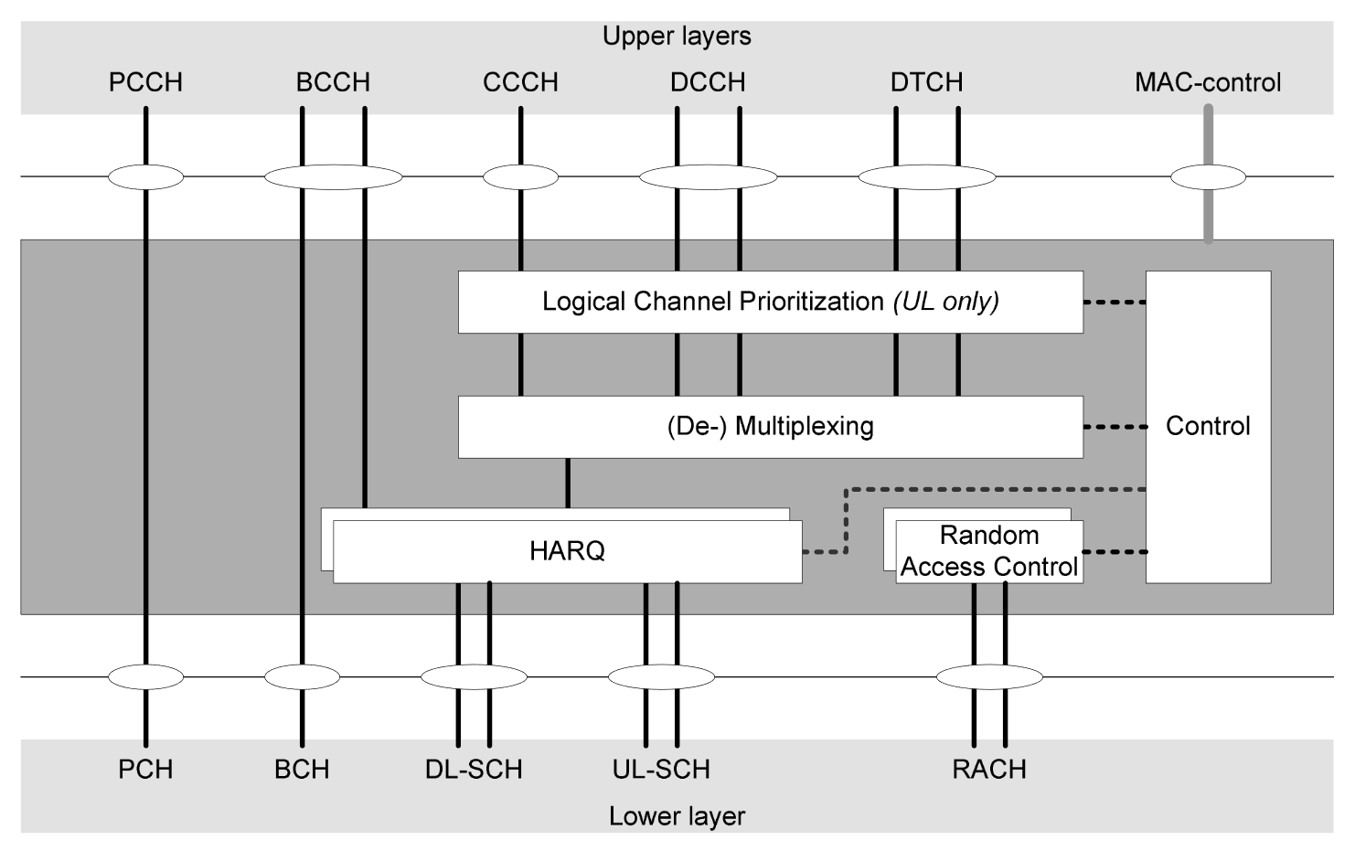  
Understanding the Diagram

Imagine you have a big machine that helps many people talk to each other by sending messages. This machine has different parts that work together to make sure the messages get to the right people at the right time.

#### Upper Layers

* **PCCH, BCCH, CCCH, DCCH, DTCH, MAC-control**: These are different types of messages that people can send and receive. Think of them like different types of mail: some are for everyone (like flyers), some are for specific groups (like a newsletter), and some are for just one person (like a letter).

#### Lower Layers

* **PCH, BCH, DL-SCH, UL-SCH, RACH**: These are like the roads and paths that the messages travel on. Different roads are used for different types of messages.

### The Parts of the Machine (MAC Layer)

1. **Logical Channel Prioritization (UL only)**:
   * This part decides which message should be sent first if there are many messages waiting. It makes sure important messages go first.
2. **(De-) Multiplexing**:
   * This part combines small messages into one big message or splits a big message into smaller parts, making it easier to send and receive.
3. **HARQ (Hybrid Automatic Repeat reQuest)**:
   * This part checks if the message was received correctly. If it wasn’t, it sends the message again until it gets through correctly. It’s like making sure a letter gets to the right person even if the mailman has to try a few times.
4. **Control**:
   * This part manages special instructions and settings, like telling the machine to wake up or sleep to save energy.
5. **Random Access Control**:
   * This part helps a new person start talking to the machine. It’s like ringing a doorbell to ask if you can come in and start sending messages.

### How It Works Together

* **Messages (Upper Layers)**: Different types of messages are sent by people.
* **Prioritization**: The machine decides which messages to send first.
* **Multiplexing**: The machine combines or splits messages as needed.
* **HARQ**: The machine checks if messages are received correctly and resends if needed.
* **Control**: The machine handles special instructions.
* **Random Access**: New people can start sending messages by asking the machine for permission.
* **Travel Paths (Lower Layers)**: The messages travel on different paths to reach their destination.

So, this machine, with all its parts working together, makes sure everyone’s messages get to the right place in the right order, even if it has to try a few times to make sure they’re delivered correctly.